# MILESTONE 2:

Project Title: IPad/Tablet Restaurant Ordering Application (IROA)

# Project Specifications:

## Problem Description:

When Customers go out to eat, they expect to have good food as well as good service. Most servers try to do their best and do a good job, but customer complaints might be justified if the wait staff is rude or does a poor job. In this case, Customers are justified in bringing their complaints to the manager and the manager would have to deal with the situation.

In addition, waiter staff is constantly checking up on guest in case they are in need of their services. Currently, in the local market, they aren’t a mechanism is a place for servers to know if a table requires their assistants without disturbing the guest or having the customer signal to the waiter for their services.

Another problem that was observed is that many restaurants store all of their data manually. As a result, these businesses have large volumes of information and it becomes a challenge to maintain, store the records accurately. It takes a lot of time to enter these large volumes of information and there are chances of mistakes.

## Project Description:

The IPad/Tablet Restaurant Ordering Application (IROA) aims to replace the conventional menu ordering system which is time-consuming and old fashioned. Meal orders can be taken on an IPad/Tablet, which will have the complete menu offered by the restaurant. Each menu item, under any of the categories, comes with a description of the dish as well as ratings given by previous customers, a large image for better knowledge of the dish and the cost of the item.

When the Customer places an order it would go directly to the kitchen to be prepared. Customers would also be able to call the waiter with the touch of a button as well as to view their outstanding bill. When the Restaurant is out of a particular stock, those items will be removed from across all devices by the restaurant and won't be visible to the customer.

## 

## Goal(s) of the System:

We have designed a solution that can make a difference in restaurants with the main goal to maintain the restaurant's functions in an effective and accurate manner as well as the day to day food records in the system. We hope that this system would impact the restaurant owners in an effective and change the experience of the customer.

# Requirements Determination:

## 

## User Requirements:

UR1: users should require minimum knowledge to operate the system

UR2: users should be able to clearly read items

UR3: users should be able to clearly identify menu options based on the pictures provided

UR4: users should be able to call a waiter when it is needed.

UR5: users should be able to see how long their order will be

UR6: users should be able to rely on the application

UR7: the user interface should be menu-driven

## System Requirements

SR1: The system should be able to show the customers the food options that are available at the restaurant.

SR2: The system should be able to remove a particular menu item when it is out of stock.

SR3: The system should be able to notify a waiter when there needed at their table.

SR4: The system should allow the customer to view the image, ratings, cost of a particular dish before the customer orders that item.

SR4: The system should send the order to the kitchen staff or bar staff.

SR5: The system should allow kitchen staff to update the order to ready and then notify the waiter when the order is ready.

SR6: The system should allow customers to click “view Bill” and the system would show the updated current standing of their bill.

SR7: The System should allow kitchen staff to reopen and cancel orders if required.

SR8: The system should allow the cashier to login to the system and accept Payments.

SR9: The system would show a list of categories for the user to select from.

## Functional Requirements

FR1: A user should be able to order a meal or meals from the menu.

FR2: A user should be able to navigate through the restaurant’s menu.

FR3: A user should be able to review their order before confirmation

FR4: A user should be able to remove a meal or meals on their order

FR5: A user should be able to request the service of a waiter

FR6: A user should be able to view their bill

## Non-Functional Requirements

NFR1: Usability - The Restaurant Ordering system should be user-friendly even for novice users and easy to learn.

NFR2: Real-time Updates: The system should be updated after a menu record is added or if a menu item is no longer available

NFR3: Time Constraints: The system should be able to respond to user interactions within 2 seconds.

NFR4: Fault-tolerant: The system should continue its normal operations despite the presence of system or hardware faults

NFR5: Scalability: The system should continue to function well when a change has occurred in size or volume in order to meet the users needs or demands.

# Diagrams:

## UML Use Case Diagram:

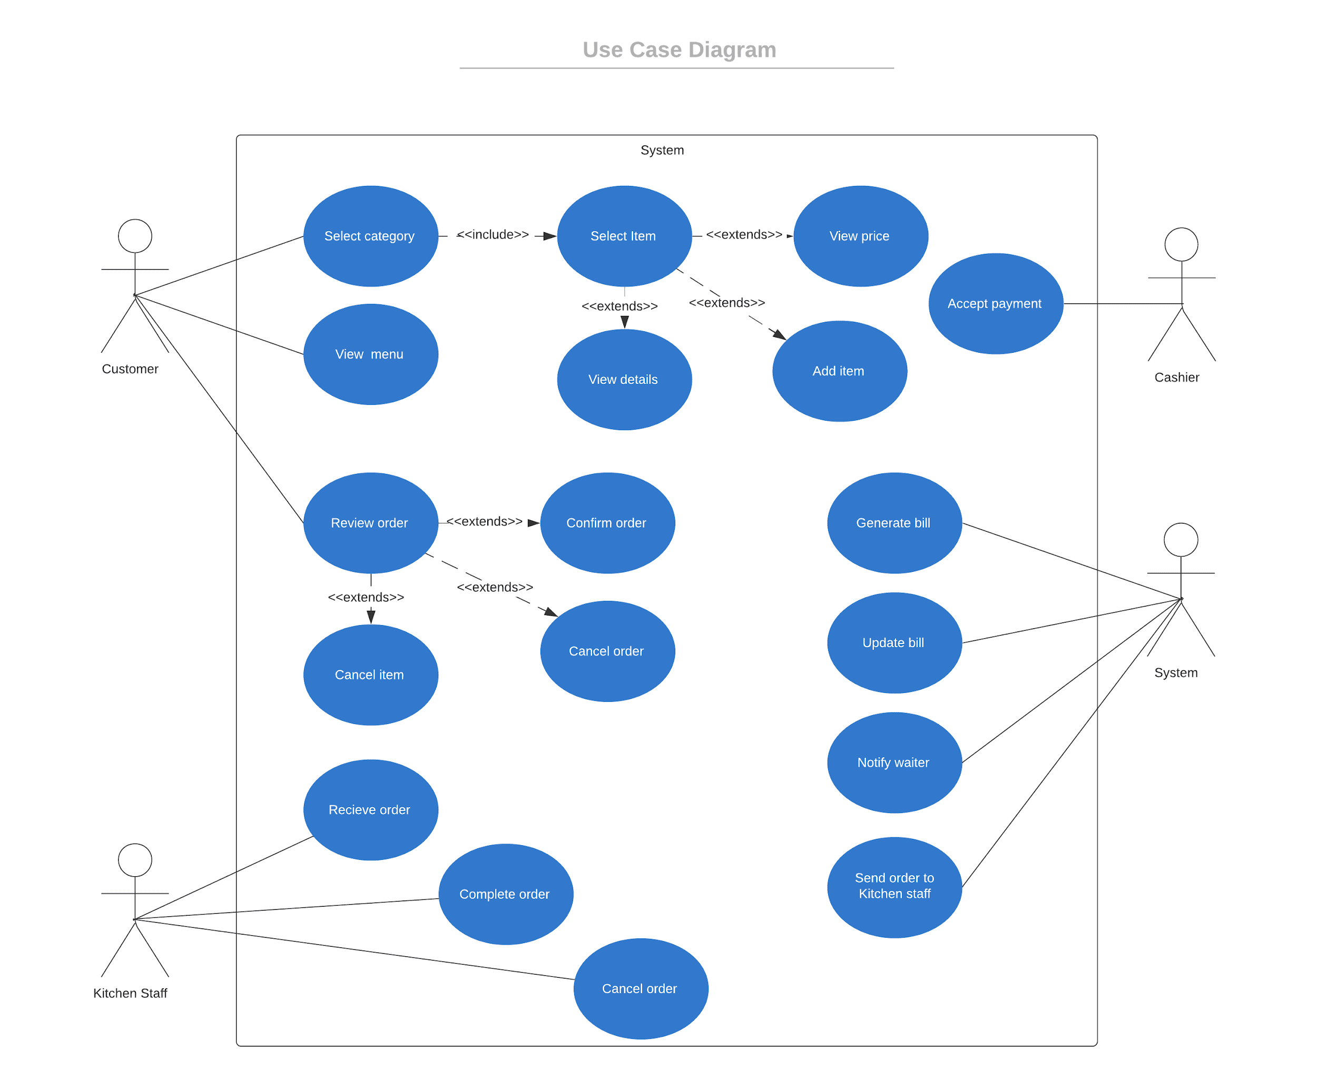

## 

## Activity Diagram:



 